

SIF Change Proposal: Assessment
Object Name: StudentResponseSet

Submitted by: Assessment
Version: v1.1
Date Submitted: July 22, 2008

Table of Contents

Rationale 2
Business Case 2
Time Line 2
Object Dependencies and Relation Map 2
Object Change 3
XML Example 3
Changes to Other Objects 2
Infrastructure Changes 2

Draft Specification Document Version Control
Version | Date: | Author/Organization: | Comments
V1.0 | 7/22/08 | Jill Abbott/SIFA | Initial draft based on input from work group
V1.1 |  | Doug Martinson | Added details
 |  | AWG | Reviewed

Change Proposal and Plan

Rationale for Change
The StudentResponseSet provides information about a student’s responses to individual items for an assessment subtest. There is a need to know the individual scores on each assessment item. The desire is to add this element.

Business Case
A school district provides information to teachers about students’ scores on assessments. In order to provide granular information about a student’s performance on each individual assessment item, it is important to know what the individual response, by student, on each assessment item is necessary. This analysis will provide the teacher with additional information about a student’s response on each specific item.

Use Case # 1 | Title: Provide Item score details  SIFObject: StudentResponseSet  Use Case Number: 2.4Activity - 1  History: new  Date: August 17, 2008
Use Case Type (Mandatory or Optional) | Optional
SIF Versions and References | SIF Implementation Specification 2.4
Summary | A teacher needs to know the performance of a student on s specific item.
Actors | Primary: Learning Management System Agent (Teacher)  Secondary:
Preconditions | - Assessment has been scored.
Outcomes | The teacher has visibility to the student performance on an individual item.
Action Steps
Variations
Exceptions
SIF System Services
Open Issues

Time Line
This change is targeted for the 2.4 Implementation Specification.

Object Dependencies and Relation Map

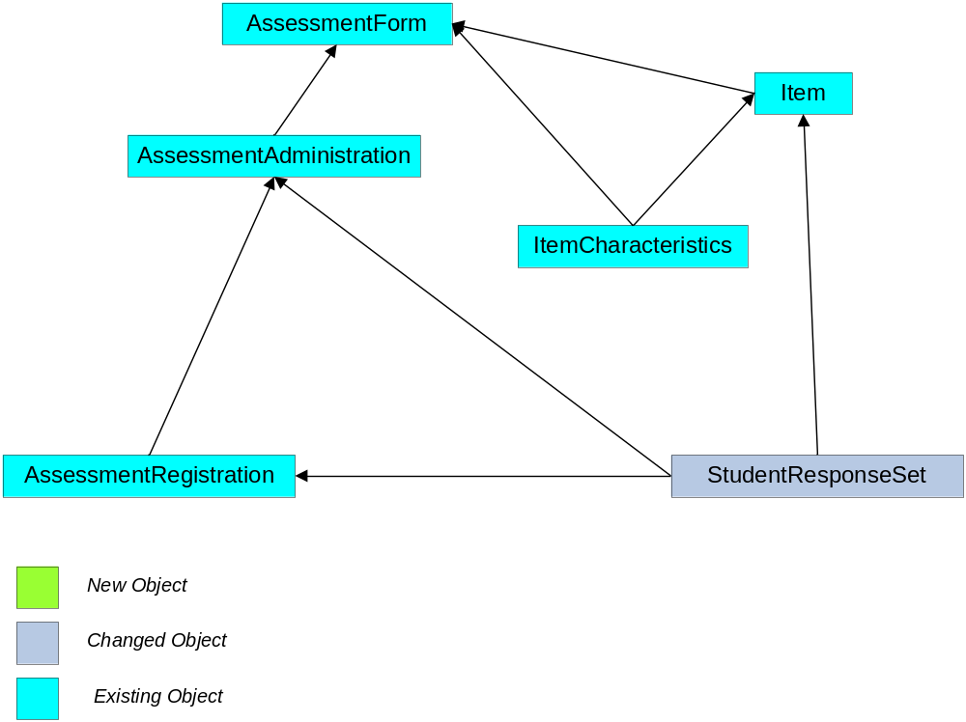

Object Changes

This new element should be added after ResponseTime. The structure will be fleshed out in additional conversations within the Assessment Work Group.

Object | Element | Attribute | Object Description
StudentResponseSet | ItemScore | O | This is the score the student received on the specific item. | xs:normalizedstring
 | ItemAidSetUsed |  | A tool or aid set used while viewing the item | Xs:string

XML Example
<StudentResponseSet RefId="A32F55CC14004172A7CD8E8FB5187DD0" AssessmentAdministrationRefId="BB181B05598C46D2B8D533483D91392E" StudentPersonalRefId="8F0934CC2F0448F8BBD788AA1ADE691B">
<Items>
<Item>
<Response>C</Response>
<ResponseLocation>http://assessments-r-
us.com/29834928374/2394/response.html</ResponseLocation>
<ResponseStatus>Incomplete</ResponseStatus>
<ResponseTime>PT32S</ResponseTime>
<ItemNumber>27</ItemNumber>
<ItemName>Writing Sample 1</ItemName>
<ItemScore>5</ItemScore>
<ItemAidSetUsed>Calculater</ItemAidSetUsed>
<DiagnosticStatement>Shows ability to determine
symmetry</DiagnosticStatement>
<NumberOfAttempts>2</NumberOfAttempts>
</Item>
</Items>
</StudentResponseSet>

Changes to Other Objects
There are no anticipated changes to other objects.

Infrastructure Changes
There are no anticipated changes or impacts to the infrastructure

